To :

Bill Brockmann

Edward.L.Williams@us.army.mil

TECHNICAL ISSUES:

HPS FRANCE 40 is NOT compatible with Windows Vista.

To install the mod, just unzip the file in France 40 folder, overwriting all files.

HPS game is set to year 1940. Though you see 1940 on the screen, just figure out scenario time is in fact: 1941.

FEATURED SCENARIOS:

#01: regular scenario. French units are located in France, and have to be moved in Belgium in response to German attack
#02: Same as above, except French units are showed in their final dispositions inside Belgium, though fixed until their theorical date of arrival.
#03: Same as above, except that French 7th army is kept in reserve.

FRANCE 41 UCHRONIA

TOPIC:

Invasion of France, Fall Gelb, occurring in June 1941 instead of May 1940

OVERALL STRATEGIC SITUATION:

UNDER CONSTRUCTION

POLAND: Invaded by Germany in 1939 after a tough fight (tougher than in historical invasion). Germany builds an “Ostwall” on the border with Soviet Union.

DENMARK – NORWAY: Invaded by Germany in April 1940.

YUGOSLAVIA – GREECE: Invaded by Germany in early autumn 1940. France and Britain sent an expeditionary corps to help both (troops who fought in Norway). Allied forces remain in Crete, Corfu.

BALKANS: all Balkan countries join Germany and found an alliance to deter an attack by Soviet Union, and to try to bring Turkey into the war along Germany side.

SOVIET UNION: Insufficient logistics prevent them from attacking Germany in 1941. Also strong military forces in the eastern border with Japan and in the south against Balkan and Turkey are necessary. Therefore, German eastern border is quiet.

USA: Well, Pearl Harbour occurred in December 1941.

BELLIGERENT PLANNING:

BELGIUM:

Invasion of Greece, Yugoslavia, Denmark, Norway, showed to the Belgians that neutrality is not an option to protect against Hitler. Therefore, Belgium slowly moves from its neutrality posture and closes towards the allies. Military cooperation is improved and the defence of Franco Belgian border is neglected, allowing for a faster deployment of French forces in Belgium in case of a German attack. Otherwise, Belgian war effort is negligible, only a modernization of the artillery and the air force is achieved.

FRANCE:

The French did not change a lot their strategy. Still relying on the Maginot line, French expect to enter in Belgium only to protect northern France’s industrial areas. No offensive operations against Germany are planned before 1942. Military operations are planned against Italy in Libya in case Italy joins Germany in the war. The operations against Germany in Norway and in the Balkans provided few experience against German tanks, because of the country land features. Therefore, still no adequate tactics against Blitzkrieg is developed. Armoured units remains in their previous roles: DLMs as cavalry covering forces, DCRs as reserve armoured counterattack forces. A lot of tanks are scattered with the infantry units. So most of the progresses made in the armoured corps are wasted by inadequate tactics.
On a positive side, the battles in Balkans and Norway allowed some experience to be gained for the troops involved there. A strong expeditionary force is made from the CEFS. It will be launched as a spearhead of the French forces to secure ANTWERP, and then later joined by the French 7th Army and a Canadian corps.

GERMANY:

Instead of choosing between a WW1 type offensive and the may 1940 Sedan breakthrough, Germans are able to do BOTH strategies. Two “panzer gruppen” will be launched through the Meuse towards the channel to isolate the allied forces in the North. Another “panzer gruppe” will attack in Belgium to pinpoint the allied forces there and push them towards the sea. A smaller “panzer gruppe” will seize ANTWERP. Some diversionary attacks will be launched against westernmost parts of the Maginot line.

Game effects: Fighting will occur on all part of the map, making a more active game. Scattering of objective hexes over the map on bridges, major towns and forts will help to achieve that effect.

ALTERNATIVE GAME FEATURES:

- Different units database. Values are enhanced for the specific role of each unit. Whether a unit as an assault unit, a defensive unit, a firing unit is depicted in the game. A lot is inspired from Mc Namara database: artillery is less effective in anti tank role, lower mechanised infantry units defensive values, etc…
- Distinction between bridge engineers and normal engineers. Not all engineers have bridge functions.
- Dozens of new historical units.
- Hundreds of new units icons.
- FORTIFICATIONS are now displayed. Maginot line’s forts, as well as Belgian forts are available, together with their garrison, armament. Their defensive value is high. On the opposite, the attacker receives new anti fortifications units: heavy siege artillery, demolition assault pioneers, etc. Taking a fort is a battle in itself.
- VICTORY POINTS hexes are scattered over most important places: bridges, forts, towns, so the A/I can act more realistically (this feature has been tested in my previous Napoleonic mods, and proved to work in some extent).
- UNITS QUALITY is altered to display more differences between units (Belgian grenadiers, French active units. Allied armies have an average “C”, German an average “B”.
- PARAMETERS CHANGE: allied artillery, supplies, are better, as well as its interdiction level (well, we are in 1941), though Germany remains superior.

NEW UNITS:

(note : most of the time only new units are showed, not all though.)

FRANCE:

UNITS that should have been available in 1941 are in play. Most of new units are French, due to the French technological and industrial advance in 1940, only to be effective in 1941. A lot of literature is available in France about war effort, industrial production and planned equipment, allowing for realistic database.

Char D2 lance flame : a stock of old D2 medium tanks remained. They were changed to flame thrower tanks.
Somua S-40 : Improved version of Somua S35 tank, with better engine, armour and suspension. Still with a one man turret though …
Somua S-41 : Much impoved version of the former with a two men turret with a 47mm AT gun.
Renault R-40
Hotchkiss H-39 : improved versions of previous Hotckiss H35 and Renault R35 with an antitank gun.
B1-ter : Improved B1bis heavy tank, with better armour, engine, and a better operation radius. The main change is industrial, making it a more simple tank to produce.
FCM 40 : Improved FCM 36 infantry tank with a better 37mm gun, in the same way as R40 and H39 tanks.
SAu 40 : Self propelled gun on a Somua 40 basis.
SAu 41 : Self propelled gun on a Somua 41 basis.
ARL v39 : Self propelled gun on a B1 heavy tank basis. Looks like a warhammer 4000 tank …
Panhard 178 47mm : a panhard armoured car with a 47mm antitank gun.
Gendron AM39 : designed to replace AMR 33 and 35 cavalry tanks, with a harder armour.
Chasseurs Portés - Dragons Portés : These units are displayed with their Laffly, lorraine personnel carrier vehicles.
Fr Bn Alpin - Bn Inf Forteresse : new units
Fr Para cie : Yep. French had some “infanterie de l’air” paratroopers. Not a lot.
47mm TAZ M39 : improved 47mmm anti tank gun able to fire in all directions.
75mm L53 TAZ M39 : 75mm AT gum. A French counterpart to 88mm gun.
90mm HAA Gun : a heavy anti air gun with anti tank capability used by french navy.
Laffly W15 TCC : a portee with a 47mm anti tank gun
AMR ZT3 : an AMR 35 vcavalry tank with a 25mm ATk gun in a tank hunter role for reconnaissance units. Only a few were produced.
Renault UE 25mm AC : a portee with a 25mm atk gun on a renault UE “chenillette”.
105mm M35 court
105mm M34
105mm M13 long
105mm M36 long
120mm M78 de bange
155mm M17 court
155mm GPFT
155mm M17 long
155mm M18 long : Main type of French artillery guns. Some are of WW1 vintage, modernized to be towed by vehicle. In 1941, most of French artillery remains horse drawn though.

220mm M16 court
305mm M1906 RR : heavy siege gun, some on rails.

75mm M1897 (coast)
100mm (coast)
120mm M78 (coast)
138mm M24 (coast)
155mm M32L TAZ Schneider
194mm M93 TAZ (coast) : coastal defense guns. The 155mm Schneider is mobile and a powerfull unit.

Casemate 135mm howitzer
Casemate 81mm mortar
Casemate 75mm gun
Casemate MG
Casemate Mixed arms
Casemate d'infanterie : various fortifications.

Reconnaissance aircrafts
Potez 637
Potez 63.11
Bloch 174
Mureaux 115
LéO C.30
Potez 27
Mureaux 117
Bréguet 27
Potez 39

« Heavy » bombers (heavy is in game terms)
Amiot 143
Farman F 222
Amiot 354
Amiot 370
Bloch MB-162
SNCAO CAO-700
Latecoere Late-570
LéO 451

Bombers and assault aircraft
Bréguet 693
Dewoitine D770
Glenn-Martin 167 F
Bloch MB-175
Douglas DB-7
Vought 156 F
Loire-Nieuport 401
Loire-Nieuport 411

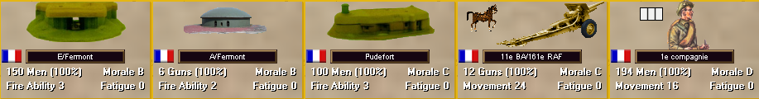

Some “fortress” units. A 105mm m1913 gun.

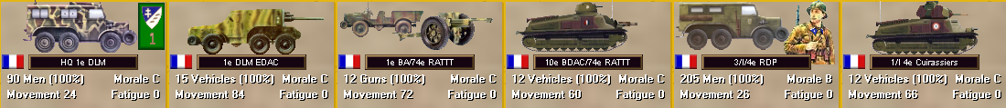

Units from a Division Légère Mécanique (DLM).

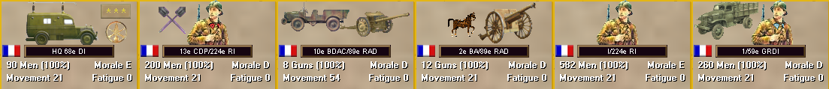

Units from an infantry division.

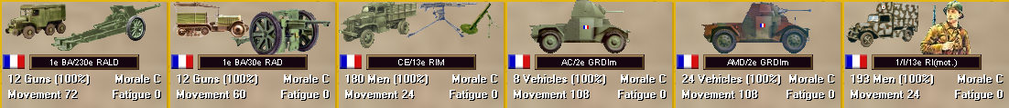

Motorized units.

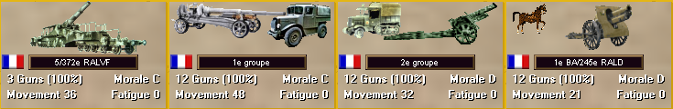

Heavy artillery.

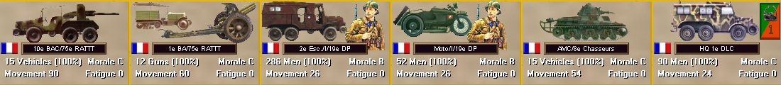

Units from a “Division Légère de Cavalerie” (DLC).

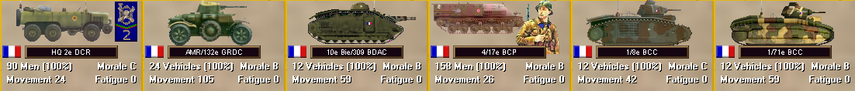

Units from a “Division Cuirassée de Réserve” (DCR).

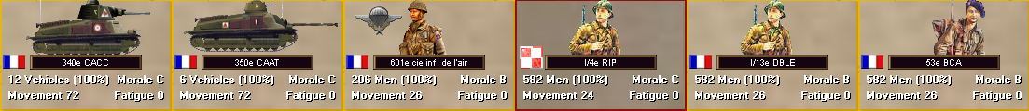

Various units.

BELGIUM:

Documentation is rare about Belgian war possibilities after 1940. Therefore, an effort is made to give a more precise touch to the units.

Grenadier Bn
Karabinier Bn Grenadier and Karabinier (somewhat) elite troops are available.
Inf Bn mot: some infantry battalions are motorized. The Belgian always made a big effort of motorizing their units.
Esc marine: some naval base guard squadrons. I love to display minor units.

TANKS

ACG-1
T15
T13
T13 b1 : Belgian had no large armoured formations. Only tank hunters T13 (in older b1 version too) are displayed.
T40 (non historical unit) : Needing a tank for its armoured force, Belgium ordered some tanks from Batignolles-Chatillon French firm. The model was build from a 1935 project rejected by the French army for its poor performances, therefore inexpensive. Only the old 37mm 1917 gun is replaced by a more modern gun. Some are available in a training unit.

Be Bn Forteresse
Eben Emael
Eben Emael det
Be det forteresse: fortified area infantry.

Mortier 12 pouces
75mm Bofors M34
75mm GPIII
75mm TR M1905
105mm GP M16
105mm M13 long
120mm FRC M31
120mm M78 de bange
150mm Krupp M16
152mm BL how
155mm M17 court
170mm Krupp
220mm M16 court
280mm Bruno SK mortar RR
305mm Vickers Mk2 how RR

Most common types of Belgian guns. Towed by horses or vehicles. Soe heavy siege artillery is available, in case the Germans are coming with some kind of mobile Siegfried line …

Casemate 150mm howitzer
Casemate 120mm howitzer
Casemate 105mm howitzer
Casemate 75mm gun
Casemate 120mm mortar
Casemate 81mm mortar
Casemate MG
Casemate Mixed arms
Casemate d'infanterie : various type of fortifications. On the whole, Belgian fortifications are inferior to French fortifications.

Air units :

Fairey Fox II & III(r)
Fairey Fox II(r)
Fairey Fox III
Fairey Fox VI(r)
Renard 31
Renard 32
Blenheim-IV
Fairey Battle
Fairey Fox VIII

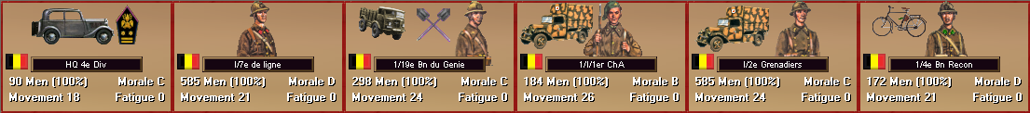

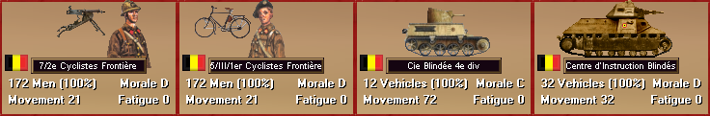

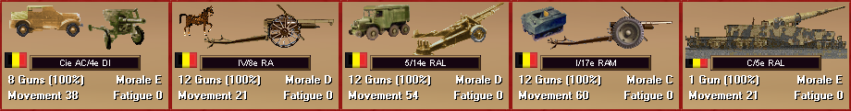

Various Belgian units. Note the T40 tank.

BRITAIN:

British units suffer from a lack of efficient tanks.

To compensate, France planned to deliver, after June 1940, one company worth of B1bis tanks to Britain.
This tank were to be equipped with a matilda turret, to compensate the lack of turrets from French industry.

Some Canadian units are available too.

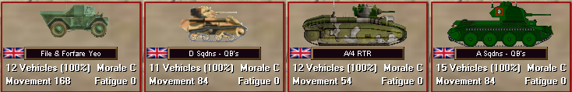

ORDER OF BATTLE AND TO/E CHANGES:

BELGIUM:

Infantry divisions have their complement of T13 antitank vehicles.

7th Infantry division is fully motorized.

Army corps artillery receives more cocquerill 120mm guns.

On the whole, Belgian army remains a defensive force.

Air force receives Hurricane fighters, Blenheim light bombers and Renard R32 locally produced reconnaissance aircrafts.

FRANCE:

“Division Cuirassée de Réserve” (DCR) : Receive a reconnaissance squadron with GENDRON SOMUA armoured cars. Addition of an additional heavy tank brigade, including new B1ter heavy tanks. The artillery component includes a group of ARL V39 assault gun. Infantry is mechanized with modern Lorraine tracked troop carriers.

“Division Légère de Cavalerie” (DLC) : The cavalry component is fully motorized. An additional group of W15 47mm antitank guns “portee” is available.

Motorized infantry divisions : two more such divisions are available, 10th and 14th. The anti tank component is reinforced by a group of 75mm TAZ m1939 modern antitank guns. Regimental batteries have 47mm antitank guns instead of 25mm.

Infantry divisions : Manpower shortage prevents creation of many new large infantry units. In addition, additional anti tank and anti air batteries absorb available additional manpower. Anti tank artillery in the divisions are reinforced with more 47mm guns. Reserve “serie B” units have some better manpower, due to introduction of new recruits to replace older soldiers. Czech volunteers are used to serve in anti tank and anti air batteries.

Other forces: artillery pursues its motorization, but still, infantry division’s artillery remains towed by horses. More polish divisions

Air force : Dewoitine D520, Arsenal VG are common fighters. An effort is made to produce bombers and Breguet assault aircraft, but, though there is a significant increase in their numbers, training, communications and tactics remains inferior to Luftwaffe’s.

GERMANY:

Germany could not match with French industry in 1940. Therefore, german strength is equivalent to Barbarossa strength.

Some tank losses were taken in the Balkans and Scandinavia in 1940-1941, compensate with new productions.

Some new models were introduced:
- Pz III with 50mm gun
- Pz V leopard: a kind of PzIV on a panther like chassis, designed in an emergency to counter French heavy tanks.

The panzer divisions each have one tank regiment to give more tactical flexibility. There are a lot of specialized and support units.

